Vocabulary and Terms
Archaeology — In Greek it means, “Study of beginnings”; it is the science that studies past cultures by excavating and analyzing their remains.
Anthropology -Anthropology is the study of humans, past and present.
Paleontology - Paleontology is the study of the history of life.
Prehistory: A time period when people lived in communities on Earth but did not write things down.
Ancient History: The study of the history of the first civilizations that wrote and kept records.
Why did they refer to people as “Hunters and Gathers?”
A hunter-gathers society obtains food from wild plants and animals. These hunter-gathers are called Nomads.
A nomad is a person with no settled home. Nomads move from place to place as a way of survival.
Ice Age
Environmental changes that took place at the end of the Ice Age:
- Glaciers melted – Oceans rose
- Larger animals disappeared
- Climate became warmer
The time from 8000 BC to 6000 BC is called the Mesolithic period or the Middle Stone Ages.
During this era, humans made useful changes in their lives to discovery and innovation.
They became skillful toolmakers and artists, wore jewelry made of bone, and continue to create paintings and drawings of animals on cave walls.
They also invented the bow and arrow, made dugout canoes from logs, and domesticated animals, including goats for food and milk, and dogs for hunting.
From 6000 BC onward, humans drastically change the way in which they produced food.
Agricultural Revolution
The discovery that plants came from seeds led to farming. Farming allowed humans to leave their nomadic way of life and form small communities. People had new roles or responsibilities.
Food came from wild plants and animals. A natural disaster could reduce the amount of food in the environment which might have a devastating effect on the peoples in nearby regions.
Around 8,000 years ago a new way of providing food emerged. This revolutionary advancement was that of farming. Instead of hunting and gathering food from the environments where they lived, humans learned to simply grow their own food.
Changes in human development made it possible for people to establish larger communities that became urban (city) settlements.
Human inventions greatly improved life.
What is a civilization?
Elements or requirements needed to be considered a “civilization.”
- surplus of food
- some form of government
- writing/language
Mesopotamia
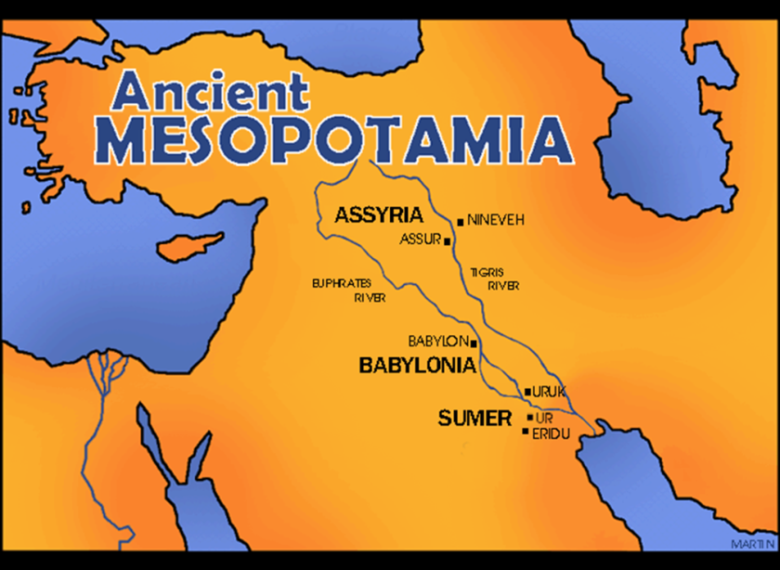

The Fertile Crescent
The "fertile crescent" refers to an ancient area of fertile soil and important rivers stretching in an arc from the Nile to the Tigris and Euphrates.
The Cradle of Civilization
The Fertile Crescent includes the modern day countries of Iraq, Syria, Lebanon, Jordan, Palestine, and others.
The yearly flooding of the Tigris and Euphrates rivers created rich soil allowing for good agriculture and early civilizations. However, the flood was unpredictable.
The Sumerians
In ancient Mesopotamia, the people who first settled down in the land between two rivers are known as the Sumerians. The civilization that grew along the riverbanks was named after one of its more famous cities, Sumer. This civilization started out arranged in small villages and towns that were agricultural in nature, with of course some hunting and fishing. The built ditches and canals to make their farmland more productive. The artificial application of water to improve farmland is called irrigation.
Terrace Farming
Irrigation and agriculture begin in earnest in Mesopotamia. Terraced farming begins and rice is cultivated.
The villages and towns gradually grew into great walled cities that traded amongst themselves as well as with other people. Each city has its own military and its own government. But the people in all the Sumerian city-states (cities) spoke the same language, believed in the same gods, and moved freely from one city-state to another, to trade and also to live. They also went to war with each other.
The laws of all the city-states were pretty much universal. Everyone knew them and was expected to obey them. This was understood.
The Sumerians believed in many gods. To the ancient Sumerians, all gods were important.
The ancient Sumerians were very clever. They invented many things to make their life more comfortable and to help their civilization grow. They put wheels on carts and probably invented the sail for sailboats. They developed the first written language, cuneiform. They invented cylinder seals, which they used to sign legal documents like contracts. They invented the first super hero, Gilgamesh. They may have invented kilns for bricks and plows for their fields. They are credited with inventing many other tools and implements to help with building and farming.
Read
With the start of the Sumerian civilization, daily life in Mesopotamia began to change. Prior to the growth of cities and large towns, people lived in small villages and most people hunted and gathered. There wasn't a lot of variety in jobs or daily life. Assyrian Musicians by Unknown With the growth of large cities, things changed. There were all sorts of jobs and activities. While many people still worked as farmers in the country, in the city a person could grow up to work in a number of different jobs such as priest, scribe, merchant, craftsman, soldier, civil servant, or laborer.
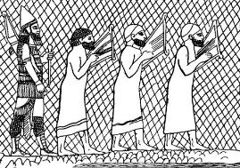

Different Classes of People - With people moving to towns and governments being formed, society was dividing into different classes of people for perhaps the first time.
At the top of society was the king and his family.
The priests were considered near the top as well.
The rest of the upper class was made up of the wealthy such as high level administrators and scribes.
Below the upper class was a small middle class made up of craftsman, merchants, and civil servants. They could make a decent living and could work hard to try and move up in class.
The lower class was made up of laborers and farmers. These people lived a harder life, but could still work their way up with hard work.
At the bottom were the slaves. Slaves were owned by the king or bought and sold among the upper class. Slaves were usually people who were captured in battle.
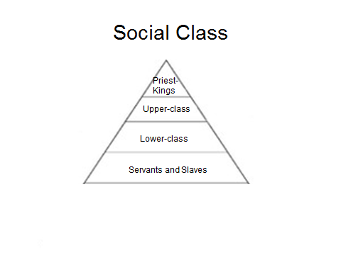
What type of homes did they live in? Most people lived in mud brick homes. They were rectangular in shape and had two to three levels. The roofs were flat and people would often sleep on the roofs during the hot summers. The mud brick worked as a good insulator and helped to keep the homes a bit cooler in the summer and warmer in the winter. Entertainment As the cities of Mesopotamia grew wealthy, there were more resources and free time for people to enjoy entertainment.
They enjoyed music at festivals including drums, lyres, flutes, and harps. They also enjoyed sports such as boxing and wrestling as well as board games and games of chance using dice. The children of the time would have had toys to play with such as tops and jump ropes. Art and poetry was a big part of the wealthier cities.
Most of the poetry and art had a religious theme or honored the king of the city. Storytellers would have passed stories down over generations with some of the more popular stories eventually being written down on clay tablets by scribes. Clothing
Clothing was typically made from sheepskin or wool. The men wore kilt-like skirts and the women wore longer dresses. They enjoyed wearing jewelry, especially rings. The women braided their long hair, while the men had long hair and beards. Both men and women wore makeup.

The civilizations of Ancient Mesopotamia brought many important advances in the areas of science and technology.
Writing - Perhaps the most important advance made by the Mesopotamians was the invention of writing by the Sumerians. Go here to learn more about Sumerian writing. With the invention of writing came the first recorded laws called Hammurabi's Code as well as the first major piece of literature called the Epic Tale of Gilgamesh.
The Wheel - Although archeologists don't know for sure who invented the wheel, the oldest wheel discovered was found in Mesopotamia. It is likely the Sumer first used the wheel in making pottery in 3500BC and then used it for their chariots in around 3200 BC.
Mathematics - The Mesopotamians used a number system with the base 60 (like we use base 10). They divided time up by 60s including a 60 second minute and a 60 minute hour, which we still use today. They also divided up the circle into 360 degrees. They had a wide knowledge of mathematics including addition, subtraction, multiplication, division, quadratic and cubic equations, and fractions. This was important in keeping track of records as well as in some of their large building projects. The Mesopotamians had formulas for figuring out the circumference and area for different geometric shapes like rectangles, circles, and triangles. Some evidence suggests that they even knew the Pythagorean Theorem long before Pythagoras wrote it down. They may have even discovered the number for pi in figuring the circumference of a circle.
Astronomy - Using their advanced math, the Mesopotamian astronomers were able to follow the movements of the stars, planets, and the Moon. One major achievement was the ability to predict the movements of several planets. This took logic, mathematics, and a scientific process. By studying the phases of the Moon, the Mesopotamians created the first calendar. It had 12 lunar months and was the predecessor for both the Jewish and Greek calendars. Medicine The Babylonians made several advances in medicine. They used logic and recorded medical history to be able to diagnose and treat illnesses with various creams and pills.
Technology - The Mesopotamians made many technological discoveries. They were the first to use the potter's wheel to make better pottery, they used irrigation to get water to their crops, they used bronze metal (and later iron metal) to make strong tools and weapons, and used looms to weave cloth from wool.
Ziggurats
In the center of each town, was the Ziggurat. The Ziggurat was a temple. The ancient Sumerians, believed their gods lived in the sky. In order for the gods to hear better, you needed to get closer to them. Ziggurats were huge, with built in steps. Ziggurats had a wide base that narrowed to a flat top. When the Babylonians took over in the south, and the Assyrians in the north, ziggurats continued to be built and used in the same manner as they were in ancient Sumer.
The Ziggurat was the tallest building in the town. From its top, you could see well into the farmlands that surrounded the city. The largest ziggurat was probably the one built in ancient Babylon. The Assyrians also built ziggurats.
Religious ceremonies were held on top of the Ziggurat. Each day, people would leave offerings to the gods of food, cloth, and wine on the steps of the ziggurat. The priests would collect and use these gifts since they were the representatives of the gods on earth.
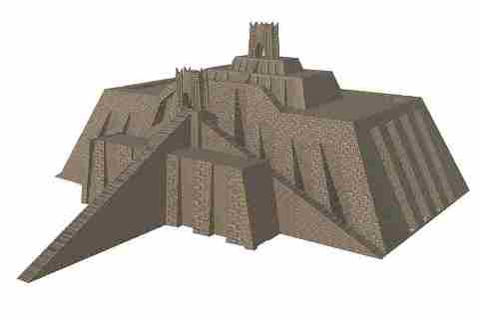

The tradition of building a ziggurat was started by the Sumerians, but other civilizations of Mesopotamia such as the Akkadians, the Babylonians, and the Assyrians also built ziggurats.
The Ziggurat of the city of Ur based on a 1939 drawing by Leonard Woolley What did they look like? Ziggurats looked like step pyramids. They would have anywhere from 2 to 7 levels or steps. Each level would be smaller than the one before. Typically the ziggurat would be square in shape at the base.
The ziggurat showed that the city was dedicated to that god. At the top of the ziggurat was a shrine to the god. The priests would perform sacrifices and other rituals here. They built them high because they wanted the shrine to be as close to the heavens as possible.
Scribes
Scribes were very important people. They were trained to write cuneiform and record many of the languages spoken in Mesopotamia.
Scribes, nearly always men, had to undergo training, and having successfully completed a curriculum became entitled to call themselves dubsar, which means 'scribe'.
The Sumerians writing system was called cuneiform.
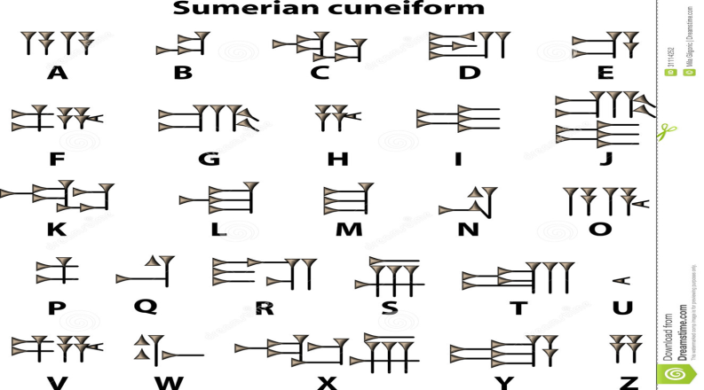
Cuneiform was made up of more than 700 symbols – called pictograms – that represented objects.
Sumerians wrote cuneiform with read writing instruments on wet clay tablets that were then baked to preserve what was written.
Mesopotamia Number System
The based 60 number system could be counted physically using the twelve knuckles on one hand the five fingers on the other hand.
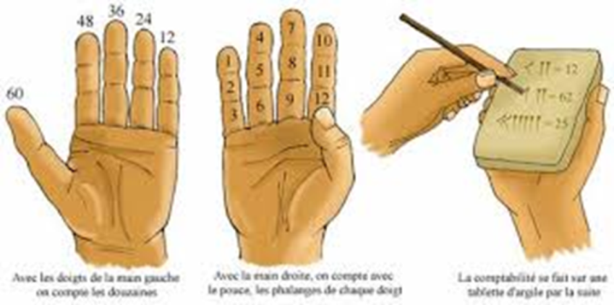
Trade Routes Developed
As civilizations grew, becoming more advanced, the demand for certain products, such as copper and tin increased. People began to desire products that were not available in their own lands, such as exotic spices, grains, animals, and so forth.
Specialized traders known as merchants organized caravans that covered distances of thousands of miles, bringing the goods and products of one society to trade them for goods and products from another society.
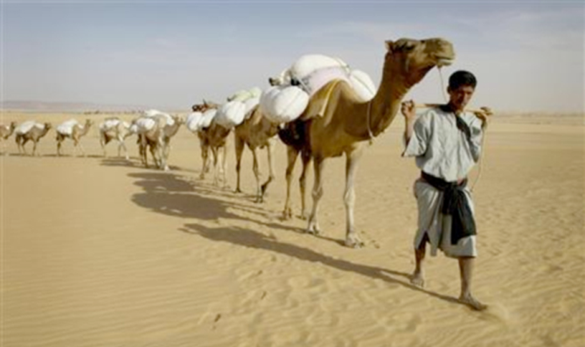
People began to desire products that were not available in their own lands, such as exotic spices, grains, animals, and so forth.
Babylon
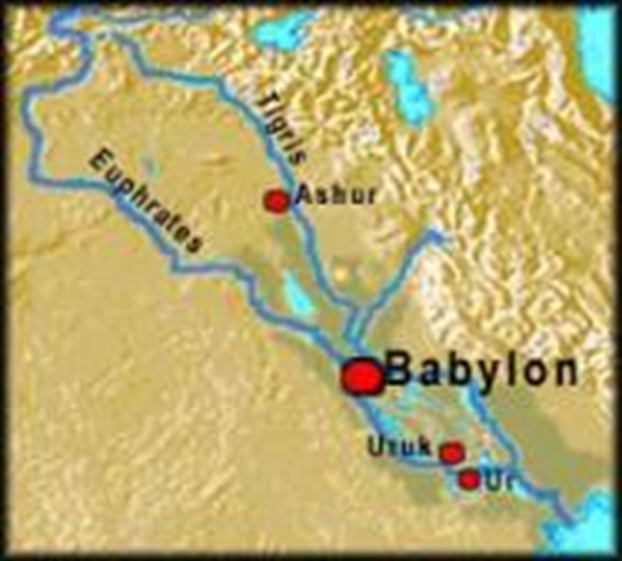
The Babylonian Empire was the most powerful state in the ancient world after the fall of the Assyrian empire (612 BCE).
The area was ruled by Hammurabi, a king of Babylon of Amorite descent (1792-1750?).

Hammurabi’s Code or The Code of Hammurabi
An Eye for an Eye
This phrase, along with the idea of written laws, goes back to ancient Mesopotamian culture that prospered long before the Bible was written or the civilizations of the Greeks or Romans flowered.
Hammurabi keenly understood that he needed one universal set of laws for all of the diverse peoples he conquered.
Therefore, he sent legal experts throughout his kingdom to gather existing laws. These laws were reviewed and some were changed or eliminated before compiling his final list of 282 laws.
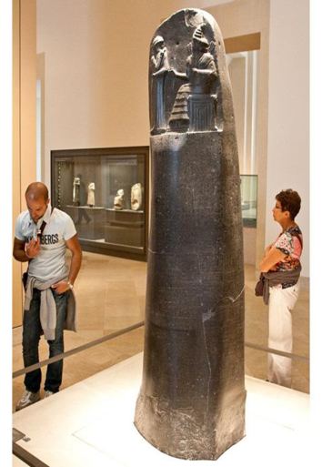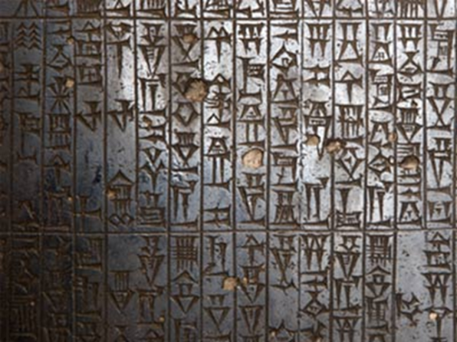
Hammurabi's Law Code was the earliest known law code in existence.
The Laws were etched into a 2 ½ meter high ( 8.2 feet) black diorite pillar, discovered in 1902.
New Babylonia
The Neo-Babylonian Empire was a period of Mesopotamian history which began in 626 BC and ended in 539 BC.
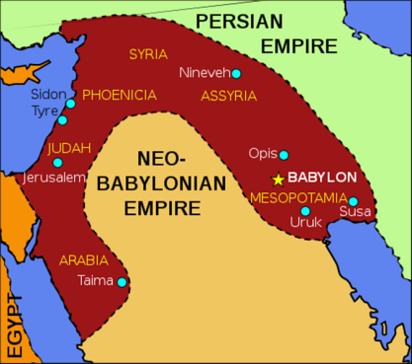

Nebuchadnezzar II was king of Babylonia from approximately 605 BC until approximately 562 BC. He is considered the greatest king of the Babylonian Empire and is credited with the construction of the Hanging Gardens of Babylon.
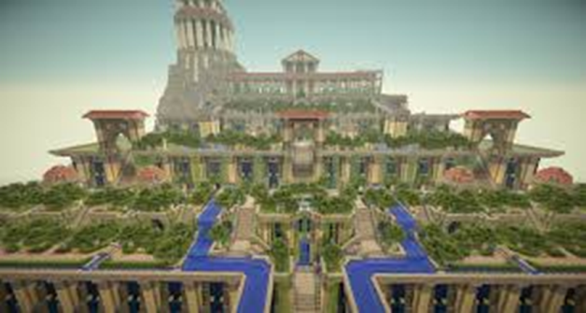
The Ishtar Gate was constructed by the Babylonian King Nebuchadnezzar II circa 575 BCE.
The Ishtar Gate was part of Nebuchadnezzar's plan to beautify his empire's capital.
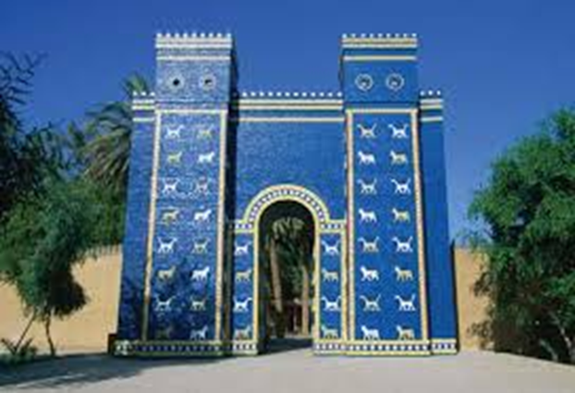
In 539 BC, however, the armies of Cyrus, king of Persia, invaded. They defeated the Babylonians in battle and captured Babylon.
Reasons for Decline
The Mesopotamian civilization declined because of two main reasons. The first is that the Mesopotamian life style was badly destroyed by war.
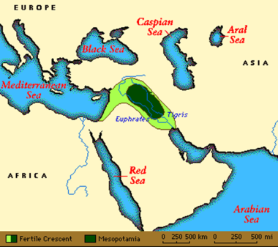

The different city-states were fighting for control of each other’s lands and would wage all out conflicts among each other to gain territory. They mostly fought for farmland and irrigation waters.
After irrigation water sits on the land, over time, the water leaves behind mineral salt which will eventually erode the farming land.
These factors on their own wouldn't have been enough to destroy the empire, but together, they brought one of the strongest empires in the world to its knees.
The land that was once Mesopotamia still exists, but it is now inhabited by the Middle East.
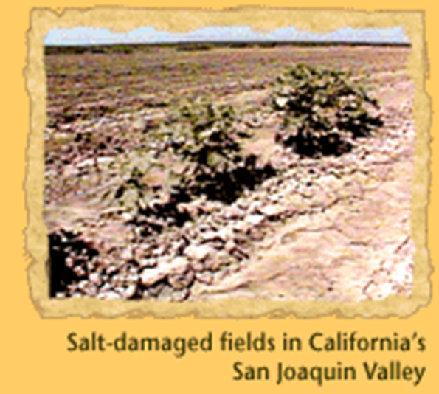Polytheism
The ancient Mesopotamians worshipped hundreds of gods, each with his/her own name and sphere of activity. Every city had its own patron god or goddess, and there were also deities connected with various professions - such as scribes and builders.
Ordinary people depended on a relationship with their own personal god - a kind of guardian angel - who protected individuals and interceded for them with the great deities. * deity or deities is another word for god and/or gods, goddesses
Monotheism
Monotheism is the belief in only one god.
- Monotheism took root in the land of Israel.
- Jews however were not fanatic about monotheism.
- Jews worshipped one god, but they did not deny that other people had their own gods.

The Ancient Hebrews
The Hebrews are named after their language called Hebrew, Hebrew is a Semitic language. Semitic: Akkadian, Arabic, Aramaic, Ethiopic, Hebrew, and Phoenician.
The Hebrews are a resilient people; while the Sumerian, Akkadian, Babylonian and Assyrian cultures have ended, the Hebrew culture continues to this day, and has had a lasting impact on our world; this despite the Hebrews being scattered, enslaved, and persecuted throughout their history.
Today their religion is known as Judaism.
A belief in one god (monotheism) forbid the Hebrews from worshipping any other gods.
According to the Torah (the first 5 books of the Bible), God told Abraham to leave Mesopotamia and travel to a new land, where he would become the father of a great nation of people.
Judaism is one of the most important world religions.
Not only is it practiced by millions of people the world over, it is also considered the origin of two other widely practiced religions: Christianity and Islam.
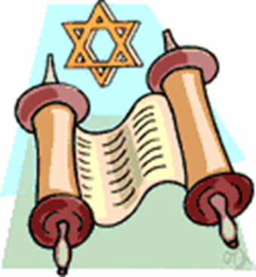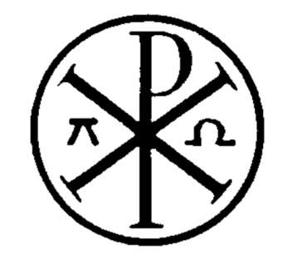
Judaism Islam Christianity (Ancient Symbol)

